TECHNICAL REPORT
Adaptive Multi-Cell Battery Intelligence System:
A Modular Embedded Architecture for Real-Time Monitoring, Protection, Diagnostics, Cloud Telemetry, and Executive Visualization
Covering Six Integrated Modules:
1. Adaptive Multi-Cell Battery Intelligence Engine
2. Event-Driven Safety Protection Kernel
3. Intelligent Embedded HMI & Diagnostic Interface
4. Fault-Tolerant Embedded Runtime System
5. Intelligent Cloud Telemetry Architecture (Blynk IoT)
6. Executive Battery Intelligence Dashboard
Submitted as a Consolidated Project Report
Embedded Systems / IoT Battery Management
July 2026

Abstract
Modern battery-powered systems - from electric mobility platforms to stationary energy storage - depend on tightly integrated intelligence spanning sensing, protection, diagnostics, connectivity, and visualization. This report consolidates six interdependent engineering tasks into a single, cohesive design for a production-grade, 4-cell lithium battery intelligence system built on an embedded microcontroller platform (Arduino/ESP32-class). The work begins with an Adaptive Multi-Cell Battery Intelligence Engine that reads analog cell voltages, computes pack averages, imbalance percentages, and cell health classifications. Building on this foundation, an Event-Driven Safety Protection Kernel implements a fully non-blocking, millis()-based finite state machine that detects weak cells, overvoltage, sensor anomalies, and rapid fluctuations, driving relay cutoffs and audible/visual alerts with anti-chatter protection and automatic recovery. An Intelligent Embedded HMI layer renders flicker-free, auto-rotating diagnostic screens on an LCD, with fault-priority override during critical events. A Fault-Tolerant Embedded Runtime System supervises the health of the platform itself, isolating faulty modules and transitioning between NORMAL, DEGRADED, FAILSAFE, and SHUTDOWN operating modes while maintaining a timestamped fault log. An Intelligent Cloud Telemetry Architecture built on the Blynk IoT platform transmits data opportunistically - on state changes and threshold violations rather than fixed intervals - while gracefully handling WiFi loss, reconnection, and event-queue synchronization. Finally, an Executive Battery Intelligence Dashboard aggregates all subsystems into a severity-coded, enterprise-style visualization with historical trends, fault history, and operator recommendations. Together, these six modules demonstrate a layered, fault-tolerant, and scalable approach to embedded battery management suitable for real-world deployment.
Keywords: Battery Management System (BMS), Cell Balancing, Embedded Finite State Machines, Non-Blocking Architecture, Fault Tolerance, IoT Telemetry, Blynk, Human-Machine Interface, Predictive Diagnostics.

Table of Contents
1. Introduction and Literature Context 4
1.1 Scope and Design Principles 4
2. Module 1 - Adaptive Multi-Cell Battery Intelligence Engine 6
3. Module 2 - Event-Driven Safety Protection Kernel 8
4. Module 3 - Intelligent Embedded HMI & Diagnostic Interface 10
5. Module 4 - Fault-Tolerant Embedded Runtime System 12
6. Module 5 - Intelligent Cloud Telemetry Architecture 14
7. Module 6 - Executive Battery Intelligence Dashboard 16
8. Cross-Module Integration Summary 18
9. Conclusion 18
References 18

1. Introduction and Literature Context
Battery Management Systems (BMS) have evolved from simple voltage-cutoff circuits into layered software-defined platforms that combine sensing, protection, diagnostics, connectivity, and analytics. Contemporary literature on lithium-ion pack management emphasizes three recurring themes that directly motivate the architecture presented here: (i) cell-level observability rather than pack-level averaging, since imbalance between individual cells is the earliest indicator of degradation or thermal risk; (ii) deterministic, non-blocking control loops, since delay()-based firmware cannot guarantee timely reaction to fast-developing faults; and (iii) layered fault tolerance, where the health-monitoring system itself must be resilient to sensor and actuator failure, not only to battery-side anomalies.
This report treats the six assigned tasks not as isolated exercises but as vertically integrated layers of one system: a sensing and analytics layer (Task 1), a real-time protection layer (Task 2), a human interface layer (Task 3), a platform self-supervision layer (Task 4), a connectivity layer (Task 5), and a presentation/analytics layer (Task 6). Figure 1 illustrates how these layers interconnect.
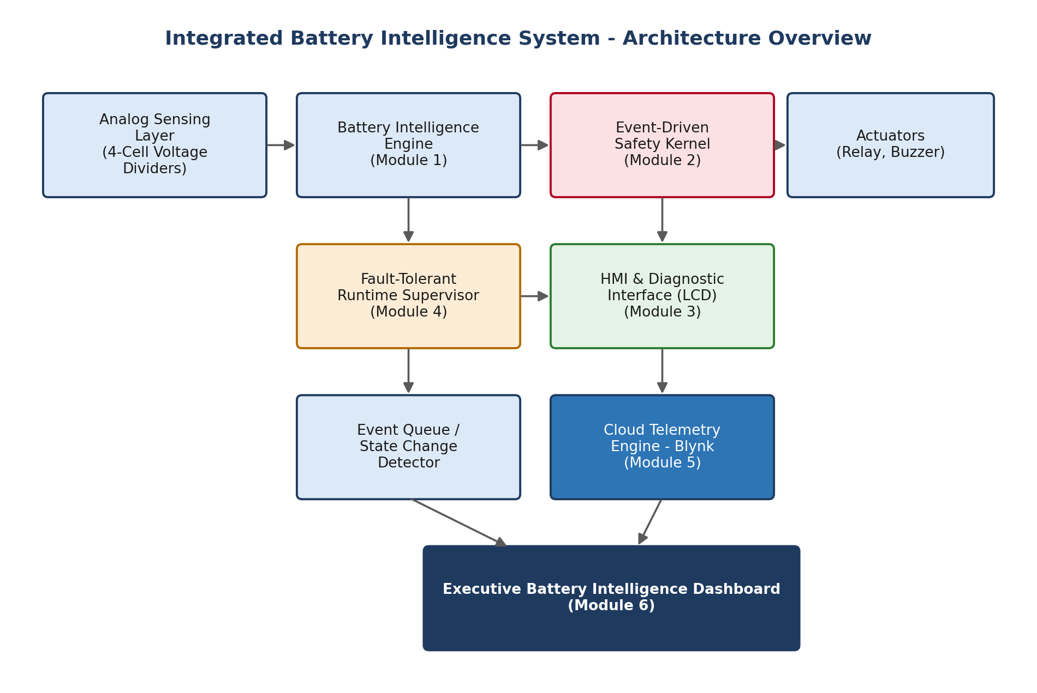
Figure 1. Integrated architecture showing data flow from analog sensing through protection, diagnostics, connectivity, and the executive dashboard.

1.1 Scope and Design Principles
- Modularity: each subsystem exposes a narrow interface (read, evaluate, act) so it can be tested and scaled independently.
- Determinism: all timing is millis()-based; no blocking delay() calls anywhere in the control path.
- Fail-safe defaults: on ambiguity (sensor disconnect, invalid ADC) the system biases toward the safer state (relay open, alert raised).
- Observability: every state transition and fault is timestamped and logged, both locally and to the cloud.
- Event-driven telemetry: cloud updates are triggered by meaningful change, conserving bandwidth and power versus fixed-interval polling.

2. Module 1 - Adaptive Multi-Cell Battery Intelligence Engine

2.1 Objective
To design a scalable engine that continuously samples four cell-voltage nodes, computes pack-level statistics, and classifies overall pack health using clearly defined, tunable thresholds.

2.2 Architecture and Data Flow
Each cell voltage is derived from a resistor-divider network feeding an ADC channel. Raw ADC counts are converted to voltage using the reference voltage and divider ratio, then passed through a lightweight moving-average filter to suppress sampling noise before analytics are computed.
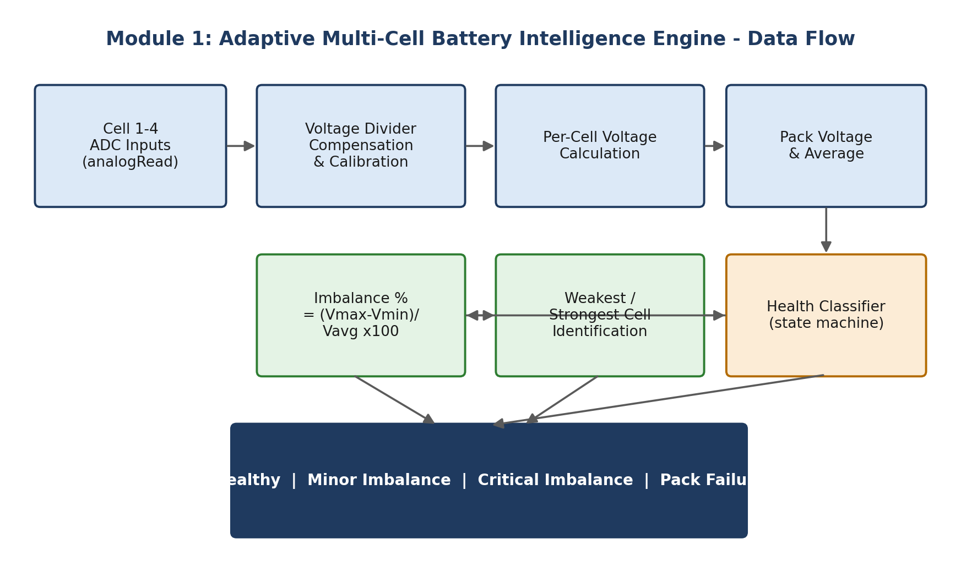
Figure 2. Signal path from ADC sampling to health classification.

2.3 Core Calculations
Metric | Formula / Logic | Purpose
Cell Voltage (Vn) | Vn = ADC_n / 4095 x Vref x DividerRatio | Per-cell measurement
Pack Voltage | Vpack = V1 + V2 + V3 + V4 | Total pack potential
Average Voltage | Vavg = Vpack / 4 | Baseline for comparison
Imbalance % | (Vmax - Vmin) / Vavg x 100 | Cell divergence indicator
Weakest / Strongest Cell | argmin(Vn) / argmax(Vn) | Targeted diagnostics

2.4 Health Classification States
State | Trigger Condition | System Response
Healthy | Imbalance < 2% and all cells within nominal range | Normal operation; green status
Minor Imbalance | Imbalance 2%-5% | Logged, flagged on HMI; no cutoff
Critical Imbalance | Imbalance 5%-10% or a cell below safe minimum | Alert raised; safety kernel engaged
Pack Failure | Imbalance > 10%, or a cell shorted/open | Relay cutoff; shutdown sequence

2.5 Scalability
The engine represents each cell as an entry in an array-of-structs rather than hard-coded variables, so extending from 4 cells to N cells requires only changing a constant and the ADC channel map - the averaging, imbalance, and classification logic are cell-count agnostic.

3. Module 2 - Event-Driven Safety Protection Kernel

3.1 Objective
To implement an automotive-grade protection controller that reacts to weak-cell, overvoltage, sensor-anomaly, and rapid-fluctuation conditions purely through event-driven, non-blocking logic, driving relay, buzzer, and LCD outputs while avoiding relay chatter.

3.2 Non-Blocking Timing Model
Every timed behavior (debounce windows, buzzer pulse duration, relay hold-off, screen alternation) is implemented with a stored millis() timestamp compared against the current tick on each loop pass, rather than delay(). This keeps the main loop free to service sensors, communications, and the HMI concurrently.
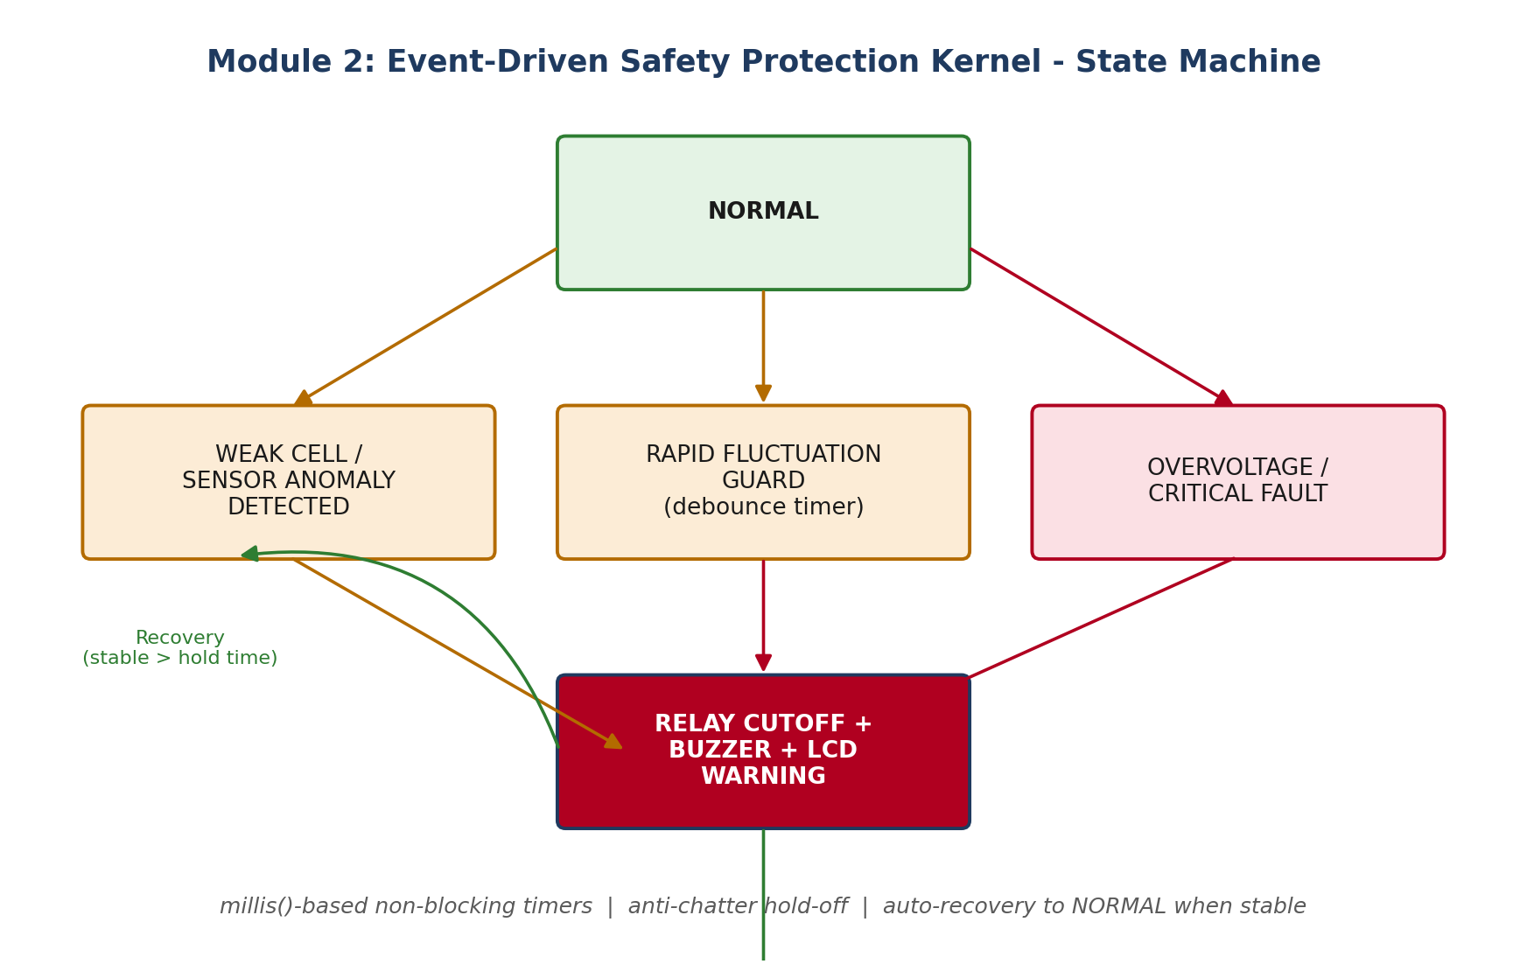
Figure 3. Safety kernel state machine, showing escalation paths and the debounced recovery path back to NORMAL.

3.3 Detected Fault Conditions
Condition | Detection Logic | Protective Action
Weak Cell | Vn < Vmin_threshold for > debounce time | Warning + prepare cutoff
Overvoltage | Vn > Vmax_threshold instantaneously | Immediate relay cutoff
Sensor Anomaly | ADC reading outside physically plausible range or frozen for N samples | Flag sensor fault; failsafe bias
Rapid Fluctuation | |dV/dt| exceeds slope threshold within sliding window | Hold-off timer before re-evaluation

3.4 Anti-Chatter and Recovery Logic
- Relay state changes are rate-limited by a minimum dwell time to prevent rapid on/off cycling under borderline conditions.
- Recovery to NORMAL requires the fault condition to remain clear for a sustained hold period, not merely a single good reading.
- All transitions are timestamped and pushed to the fault log maintained by Module 4.

4. Module 3 - Intelligent Embedded HMI & Diagnostic Interface

4.1 Objective
To provide an operator-facing LCD interface that automatically rotates between diagnostic screens, renders without flicker, and instantly prioritizes fault information when a critical condition is detected.
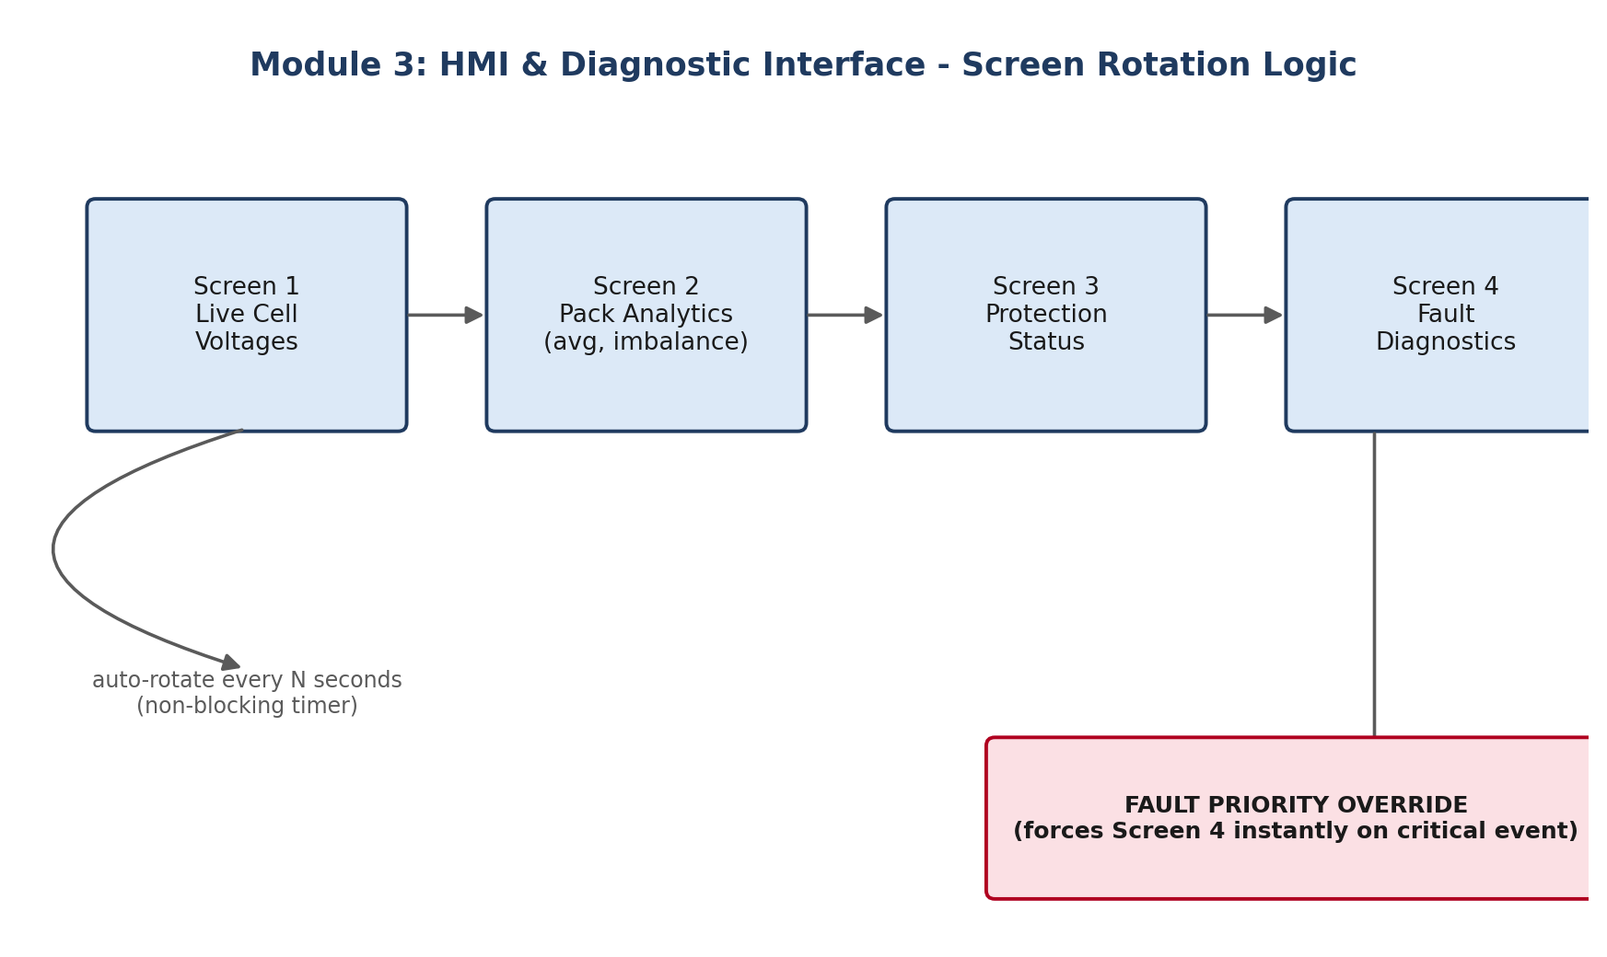
Figure 4. Screen rotation cycle with fault-priority override path.

4.2 Screen Set
Screen | Content
1 - Live Data | Real-time voltage of each of the four cells
2 - Analytics | Pack average, imbalance %, weakest/strongest cell
3 - Protection Status | Current safety-kernel state, relay/buzzer status
4 - Fault Diagnostics | Active and recent faults with timestamps

4.3 Flicker-Free Rendering
Rather than clearing and redrawing the full display each cycle, the interface tracks the previously rendered value per field and only issues an LCD write when a field's value has actually changed, minimizing visible redraw and I2C/parallel bus traffic.

4.4 Fault-Priority Override
A dedicated override flag, set by the safety kernel on entering a critical or pack-failure state, forces immediate display of the Fault Diagnostics screen regardless of the current rotation position, and suspends rotation until the fault clears.

5. Module 4 - Fault-Tolerant Embedded Runtime System

5.1 Objective
To supervise the health of the embedded platform itself - independent of battery-side faults - detecting hardware and software failures and transitioning the system through defined operational modes while isolating unhealthy modules.
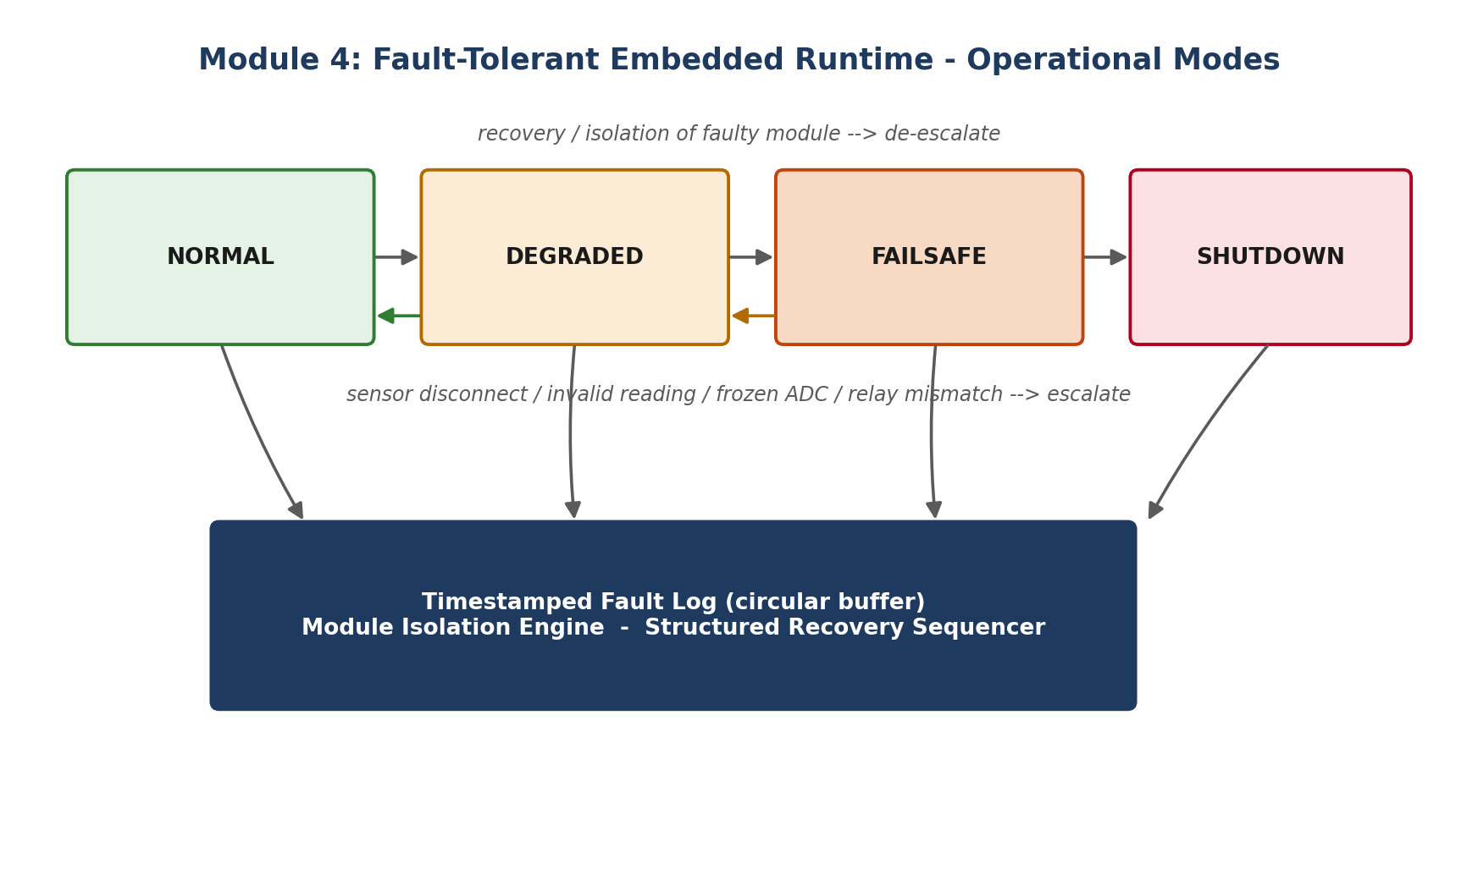
Figure 5. Operational mode transitions with escalation and de-escalation paths.

5.2 Operational Modes
Mode | Meaning | Typical Trigger
NORMAL | All modules healthy | Default state
DEGRADED | One non-critical module impaired but system still functional | Single sensor anomaly, HMI glitch
FAILSAFE | Core safety function at risk | Relay mismatch, frozen ADC on a critical channel
SHUTDOWN | Continued operation unsafe | Multiple concurrent faults, unrecoverable relay fault

5.3 Detected Failure Classes
- Sensor disconnection - open-circuit ADC signature (reading pinned at rail).
- Invalid readings - values outside physically valid bounds.
- Frozen ADC - identical raw value across many consecutive samples despite expected variation.
- Relay mismatch - commanded relay state does not match the sensed feedback state.

5.4 Isolation and Logging
Each detected fault is attributed to a specific module identifier so that a failing HMI, for example, does not force the safety kernel into shutdown - only modules whose failure genuinely compromises safety escalate the operational mode. A structured, timestamped fault log (module ID, fault code, timestamp, resolved/unresolved flag) is retained in a circular buffer for post-incident analysis and is surfaced on both the HMI and the cloud dashboard.

6. Module 5 - Intelligent Cloud Telemetry Architecture

6.1 Objective
To transmit battery and system state to the Blynk IoT cloud platform efficiently - triggered by state changes, anomalies, or threshold violations rather than a fixed polling interval - while remaining resilient to WiFi loss.
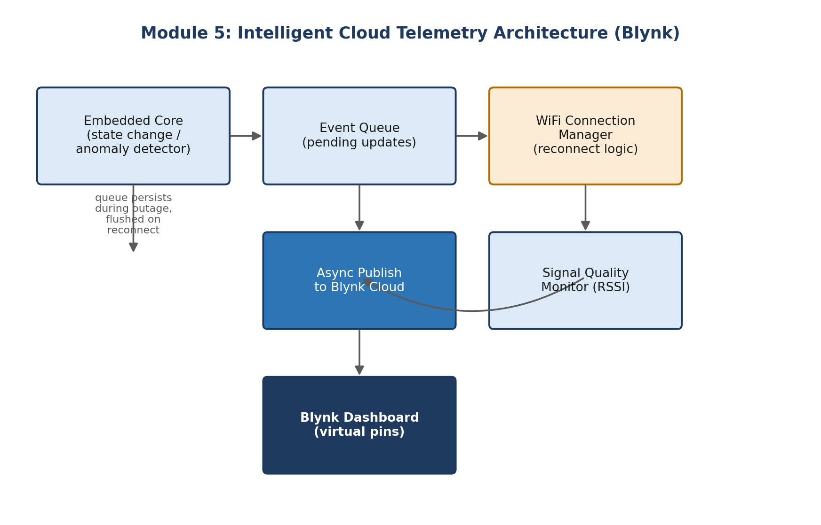
Figure 6. Event-driven telemetry pipeline with queued updates and reconnect handling.

6.2 Event-Driven Transmission Policy
Trigger | Example | Telemetry Action
State change | Health classification moves from Healthy to Minor Imbalance | Immediate virtual-pin update
Threshold violation | A cell crosses Vmin or Vmax | Immediate alert push + data update
Operational mode change | NORMAL to DEGRADED/FAILSAFE/SHUTDOWN | Immediate update + log entry sync
Heartbeat | No change for extended period | Low-frequency keep-alive only

6.3 Connectivity Resilience
- A WiFi connection manager monitors link status and attempts non-blocking, exponentially-spaced reconnection rather than blocking retries.
- Events generated while offline are held in a local queue and flushed in order once connectivity is restored, preserving chronological fault history in the cloud.
- Signal quality (RSSI) is sampled and surfaced on the dashboard so operators can distinguish a weak-signal condition from a genuine device fault.
- The embedded core (Modules 1-4) never blocks on network activity; all cloud communication is asynchronous relative to the safety and sensing loops.

7. Module 6 - Executive Battery Intelligence Dashboard

7.1 Objective
To present an enterprise-grade visualization layer that consolidates live data, historical trends, risk analysis, fault history, and actionable recommendations for a non-technical operator or manager.
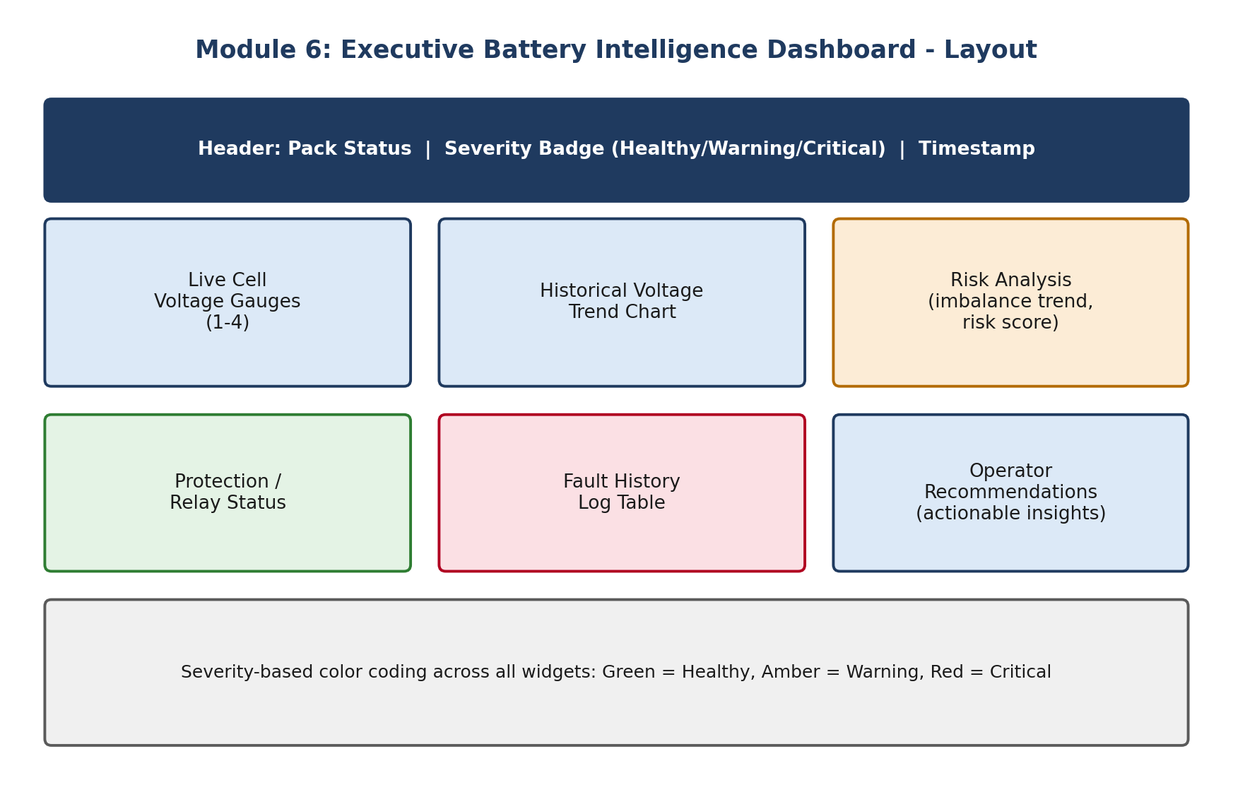
Figure 7. Executive dashboard layout with severity-based color coding.

7.2 Dashboard Components
Widget | Purpose
Live Cell Voltage Gauges | Instantaneous per-cell reading with color-coded range bands
Historical Voltage Trend | Time-series chart for pack and per-cell voltage over recent history
Risk Analysis Panel | Rolling imbalance trend and a derived composite risk score
Protection / Relay Status | Current safety-kernel state and relay/buzzer indicators
Fault History Log | Timestamped, filterable table of past and active faults
Operator Recommendations | Rule-derived guidance, e.g. schedule cell inspection, reduce load

7.3 Severity-Based Visual Language
A single color convention is applied consistently across every widget: green indicates Healthy, amber indicates Minor Imbalance or Degraded, and red indicates Critical Imbalance, Failsafe, or Shutdown. This consistency lets an operator assess overall pack risk at a glance without reading individual values.

8. Cross-Module Integration Summary
The six modules form a closed loop: Module 1 produces the analytics that Module 2 acts on; Module 2's state feeds both the HMI (Module 3) and the runtime supervisor (Module 4); Module 4 governs which faults are safe to display versus which force a shutdown; and Modules 5 and 6 mirror the same state externally for remote operators, using an event-driven rather than polling model to remain efficient and responsive.
Module | Primary Output | Consumed By
1. Battery Intelligence Engine | Voltages, imbalance %, health state | Modules 2, 3, 5, 6
2. Safety Protection Kernel | Relay/buzzer commands, protection state | Modules 3, 4, 5, 6
3. HMI & Diagnostics | On-device operator display | End operator (local)
4. Fault-Tolerant Runtime | Operational mode, fault log | Modules 3, 5, 6
5. Cloud Telemetry | Remote virtual-pin updates | Blynk cloud, Module 6
6. Executive Dashboard | Consolidated visualization | Remote operator / management

9. Conclusion
This report has presented a unified design spanning sensing and analytics, real-time protection, human-machine interfacing, platform self-supervision, cloud connectivity, and executive visualization for a 4-cell lithium battery pack. By enforcing non-blocking, millis()-based timing throughout, isolating faults at the module level, and adopting an event-driven rather than fixed-interval telemetry model, the resulting architecture is positioned to scale from a bench prototype to a field-deployable battery management system. Future extensions could include active cell balancing actuation, temperature-compensated voltage calibration, and machine-learning-based state-of-health prediction layered on top of the fault log accumulated by Module 4.

References
[1] Arduino/ESP32 platform documentation on analogRead(), millis(), and non-blocking design patterns.
[2] Blynk IoT Platform Documentation - Virtual Pins, Event Handling, and Reconnection Strategies.
[3] General literature on Battery Management Systems: cell balancing, state-of-charge estimation, and safety cutoff design principles.
[4] Embedded systems design patterns for finite state machines and fault-tolerant supervisory control.

